MANDATORY DISCLOSURE

- INSTITUTE INFORMATION

Name of Institution : CSMSS COLLEGE OF POLYTECHNIC
Address of Institution : KANCHANWADI, PAITHAN ROAD, AURANGABAD City & Pin Code : AURANGABAD (431011)
State : MAHARASHTRA

Phone Number : 0240 (2646404)

FAX Number : 0240 (2376655)

E-mail : csmsspoly@gmail.com

Website : www.csmsspoly.com

Office hours at the Institution : - 9.30 a.m. To 5.30 p.m.
Academic hours at the Institution : - 10 a.m. To 5.30 p.m
Nearest Railway Station (dist. In KM) :- Station Road, 3KM.
Type of Institution : - Private – Self Financed
College Shift : First shift
Name of the affiliation Board :- Maharashtra State Board of Technical Education, Mumbai
II. DETAILS OF ORGANIZATION
Name of Organization : CHHATRAPATI SHAHU MAHARAJ SHIKSHAN
SANSTHA
Address of Organization State : KANCHANWADI, PAITHAN ROAD, AURANGABAD : MAHARASHTRA
City & Pin Code : AURANGABAD(431011)
Website :www.csmss.com
Type of Organization : TRUST
Registered With : F-1265 Registered Date : 11TH-April-1986

III. PRINCIPAL PROFILE
NAME OF PRINCIPAL | Dr. DONGRE GANESH BALIRAM | 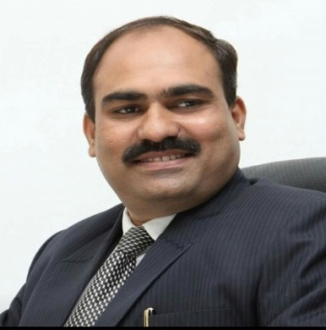
DATE OF BIRTH | 12 June 1977
ADDRESS OF PRINCIPAL | Staff Quarter, CSMSS Sanstha, Kanchanwadi, Paithan Road, Aurangabad
DATE OF JOINING | 1 June2 2009
PHONE (OFFICE)/  MOBILE NO. | 0240-2646401  9921550899
E-MAILS | ganeshbdongre@gmail.com  1152principal@msbte.com
QUALIFICATION | Ph. D. (Electronics Engineering), M.E., MBA
TOTAL EXPERIENCE | 20 Yrs.
PAPER PUBLISHED | 08 International level & 07 National level
PAPER PRESENTED IN CONFERENCE | 08
PROFESSIONAL MEMBERSHIP | Indian Society For Technical Education, New Delhi,  Joint Secretary Association of the Management of Unaided polytechnics Maharashtra state

IV. EXECUTIVE COMMITTEE MEMBERS

Sr.No | Name of Committee Members | Designation | Contact. No
1 | Hon. Shri. Ranjeet Padmakrrao Mulay | President | 0240-2646401
2 | Hon. Shri. Padmakrrao Haribhau Mulay | Secretary | 0240-2646401
3 | Hon. Shri. Sameer Padmakrrao Mulay | Member | 0240-2646401
4 | Hon. Shri. Vitthalrao Pandurang Lahane | Member | 0240-2646401
5 | Hon. Shri. Pandurang Solunke | Treasurer | 0240-2646401
6 | Hon. Smt. Lata Padmakarrao Mulay | Member | 0240-2646401
7 | Hon. Adv. Udaysing Shisode | Member | 0240-2646401

REQUENCY OF MEETING :- Half Yearly

V. LOCAL GOVERNING COMMITTEE:

Sr.No | Name of Committee  Members | Designation | Official Address & contact. No.
1 | Mr. Ranjeet P. Mulay | Chairman | Kanchanwadi, Aurangabad
2 | Mr. Padmakar H. Mulay | Member | Kanchanwadi, AUrangabad
3 | Mr. Sameer P. Mulay | Member | Kanchanwadi, Aurangabad
4 | Mr. Vitthal P. Lahane | Member | Kanchanwadi, Aurangabad
5 | Mr. Nitin S. Bagve | Member | Kanchanwadi, Aurangabad
6 | Dr. Shrikant Gunajirao Deshmukh | Member | Kanchanwadi, Aurangabad
7 | Nominee R.O. AICTE | Member | Mumbai-400087
8 | Mr. Mahesh D. Shivankar (Nominee DTE RO, Aurangabad) | Member | Aurangabad
9 | Mr. Pramod U. Wayse  (Nominee MSBTE RO, Aurangabad) | Member | Aurangabad
10 | Nominee State Govt. | Member | Mumabai
11 | Mr. Shahane V. N. | Member | Kanchanwadi, Aurangabad
12 | Mrs. Manisha B. Sakhare | Member | Itkheda, Aurangabad
13 | Prof. Ganesh Baliram Dongre | Member Secretary | Kanchanwadi, Aurangabad

FREQUENCY OF MEETING MEETING :- Half Yearly

VI. ORGNIZATIONAL CHART

Executive Body of Trust

Local Governing Council

1.Principal  2.Registrar  3.Management person  4.Faculty members | Students self-help groups  Students Council | - Parent Council  - Parent teacher  Association

Student Feedback on Institutional Governance / Faculty performance.
Student feedback is regularly taken for quality improvement, And faculty appraisal. The Points in the feedback are:
  - Preparation of the faculty for lectures.
  - Presentation Skills.
  - Communication Skills.
  - Interactive Teaching.
  - Relevance to the topic.
  - Percentage of syllabus covered.
  - Availability of the staff outside class rooms, etc.
In the addition to this, suggestion box is kept outside Principal’s office for students.

Grievance redressal mechanism for faculty, staff and students.
Yes, As per Government. Norms Committee are available on www.csmss.org

VII. DETAILS OF PROGRAMMES
Title |  | Civil Engineering. | Computer Engineering | Electrical Engineering | Electronics & Tele comm. Engineering. | Mechanical Engineering

AICTE Approval no.
Duration |  | 3 Years | 3 Years | 3 Years | 3 Years | 3 Years
Number of Seats |  | 60 | 90 | 60 | 30 | 90
Year wise Actual Admission (First Year) |  | 21-22 : 30  20-21 : 41  19-20 : 33 | 21-22 : 104  20-21 : 95  19-20 : 63 | 20-21 : 61  20-21 : 61  19-20 : 56 | 21-22 : 33  20-21 : 36  19-20 : 30 | 21-22 : 66  20-21 : 66  19-20 : 67
Fees Per Year (2020-21) | FY | 57,000 | 57,000 | 57,000 | 57,000 | 57,000
 | SY | 57,000 | 57,000 | 57,000 | 57,000 | 57,000
 | TY | 57,000 | 57,000 | 57,000 | 57,000 | 57,000
Cut of Marks(In %)last Three years |  | 2021-22 :57.00%  2020-21 :79.40%  2019-20 :52.80% | 2021-22 :75.80%  2020-21 :66.60%  2019-20 : 65.60% | 2021-22 :56.60%  2020-21 : 69.40%  2019-20 :55.60% | 2021-22 :50.60%  2020-21 :44.67%  2019-20 :64.00% | 2021-22 :57.00%  2020-21 :60.60%  2019-20 :44.80%
Campus Placement in last Three Years |  | 00 | 00 | 00 | 00 | 25
Minimum Salary |  | Rs. 9000/month | Nil | Rs. 9000/month | Rs. 9000/month | Rs. 9000/month
Maximum Salary |  | Rs. 18000/month | Nil | Rs. 18000/month | Rs. 18000/month | Rs. 18000/month

VIII. PROFESSIONAL ACTIVITIES

Average Pay package, Rs./year | : Average salary Rs 1.5 Lakh
Students opted for Higher Studies | : Approx. 85% students opted for Higher Studies
Accreditation Status of the course | :- 3 course Computer Engg, Electronics and Tele. Com. Engg. And Mechanical Engg. Applied for National Board of Accreditation (NBA) New Delhi
Professional Society Memberships | : ISTE Institute Membership
Life Membership of Staff | :- ISTE
Consultancy activities | NIL

IX. Branch Wise Laboratories:

Sr.no. | Program Name | No. of Laboratories
1 | Civil Engineering (CE) | 8
2 | Computer Engineering (CO) | 14
3 | Electrical Engineering (EE) | 5
4 | Electronics & Telecommunication Engineering (EJ) | 6
5 | Mechanical Engineering (ME) | 12
6 | Applied Science | 4

X. LIBRARY - DETAILS

Sr.  No. | Course | No. of Titles  Available | No. of Volumes  Available | No. of Tech Journals
 |  |  |  | National | International
1 | CE | 207 | 2019 | 6 | -
2 | CO | 209 | 1109 | 3 | -
3 | EE | 178 | 1814 | 6 | -
4 | EJ | 211 | 1030 | 3 | -
5 | ME | 215 | 4162 | 12 | -
Total |  | 1020 | 10074 | 30 | -

- LIBRARY WORKING HOURS: 8:00 a.m. to 6:00 p.m.
- READING ROOM CAPACITY: 150 Nos.
**During holidays and exam period 06.00am to 11.30pm
XI. COMPUTATIONAL FACILITY
Legal System Software | Legal Application Software | Internet Bandwidth in mbps | No. of PCs available to students | PCs available in Administrative Office | No. of PCs available to Library | No. of PCs available to Faculty Members | No. of Printers available to students
05 | 30 | 10 | 310 | 05 | 10 | 05 | 25
XII . ANTI-RAGGING RELATED DETAILS

Constitution of Anti-Ragging Committee | Yes
Constitution of Anti-Ragging Squad | Yes
Affidavit obtained from all Students | Yes
Appointment of Counselors | Yes
Affidavit obtained from Parents of all the Students | Yes
Affidavit obtained from all Students staying in Hostel | Yes
Affidavit obtained from Parents of all Students staying in Hostel | Yes

XIII.
ANTI-RAGGING COMMITTEE

S.NO. | NAME OF THE STAFF | Designation | Post
1 | Prof. Ganesh B. Dongre | Chairman | Head of Institute (Principal)
2 | Police Inspector | Member | Member, Police Dept.
3 | Mr. Sanjay Patil | Member | Local Media Representative
4 | Mr. Kerron Vaishnav | Member | NGO Representative
5 | Mr. Vikas Shahane | Member | Faculty Representative
6 | Mrs. Dhanshri Lahore | Member | Faculty Representative
7 | Mr. Bharat Dhanwade | Member | Faculty Representative
8 | Mr. Uttam Khunbhar | Member | Parent Representative
9 | Mr. Parmeshwar Dake | Member | Non-teaching representative
10 | Mr. Udawant Shantanu | Member | Student Representative
11 | Ms. Jagruti R. Nikam | Member | Student Representative

Separate Hostel facility is available for Girls & Boys having 100 beds
XIV.
HOSTEL FACILITY
capacity of each.
XV. OTHER FACILITIES
All Weather Approach (Motorized Road) | Yes
Backup Electric Supply | Yes
Barrier free Environment | Yes
CCTV Security | Yes
ERP Software | Yes
Electric Supply | Yes
General Insurance | Yes
Group Insurance | Yes
Insurance for Students | Yes
Medical & Counseling | Yes
Safety Provisions | Yes
Telephone & FAX | Yes
Seminar Hall / Auditorium Hall | Yes
Portable Water Supply
Post & Banking / ATM

XVI. COLLEGE AMENITIES

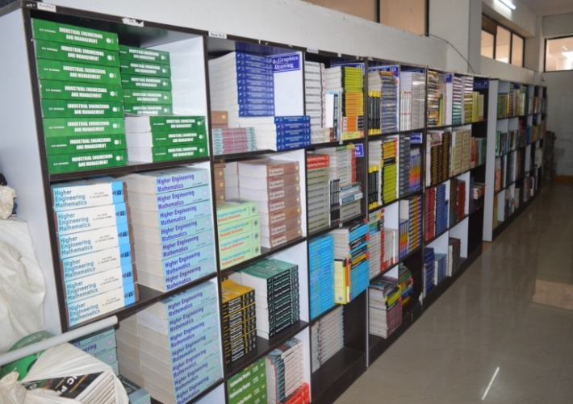
COLLEGE BUILDING LIBRARY
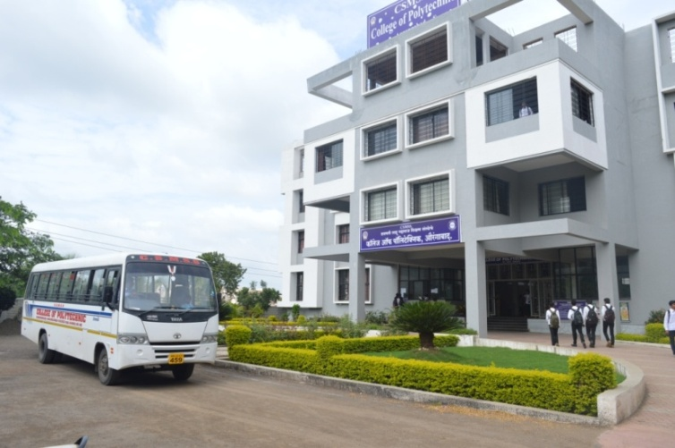
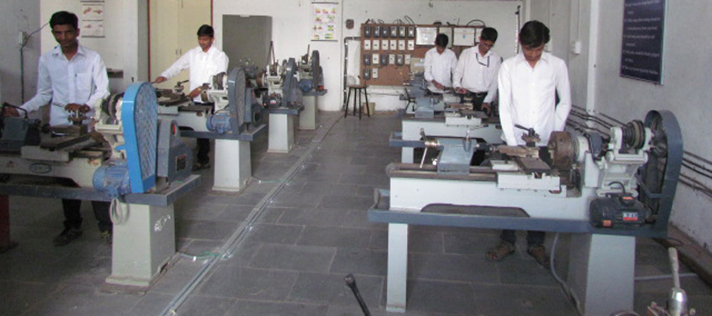
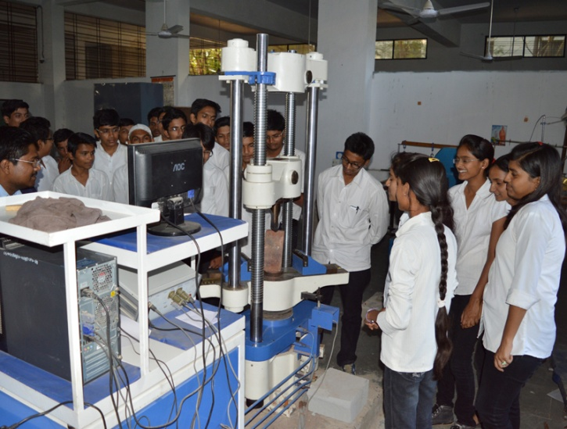
UTM MACHINE WORKSHOP

CANTEEN FACILITY HOSPITAL FACILITY
